**MINI PROJECT**

CREATE A ROBOTIC CAR TO BE CONTROLLED BY SERIAL MONITOR COMMANDS:

1. COMMANDS TAKEN SHOULD BE IN THE FORM OF STRING
2. IT SHOULD CONTAIN 2 MOTORS
3. CONSIDER CLOCKWISE AS FORWARD AND ANTICLOCKWISE AS BACKWARD
4. COMMANDS :

* FORWARD
* BACKWARD
* LEFT
* RIGHT
* STOP

**TINKERCAD – CIRCUIT DIAGRAM :**

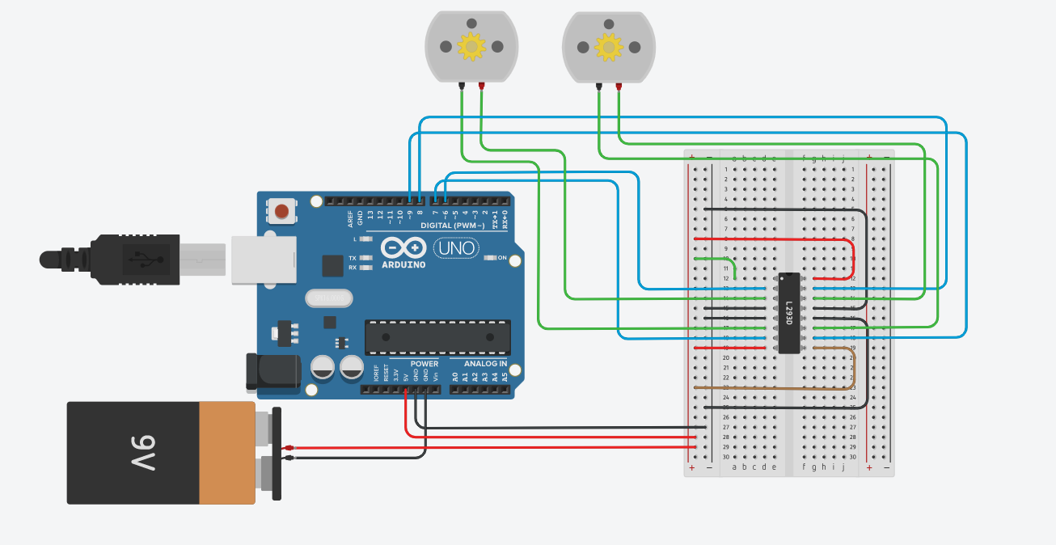

**CODING:**

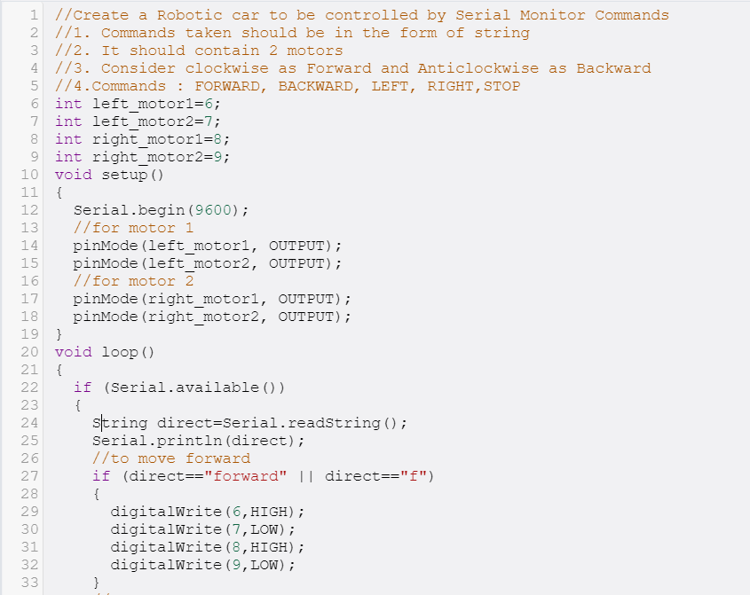

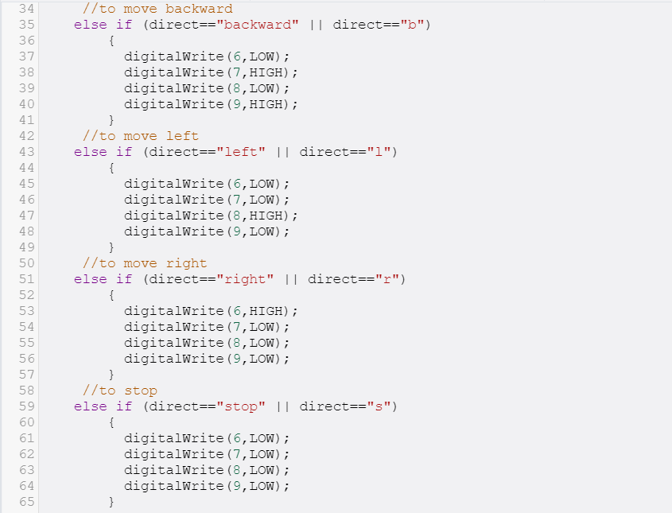

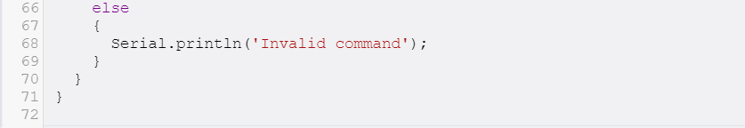

**SERIAL MONITOR:**

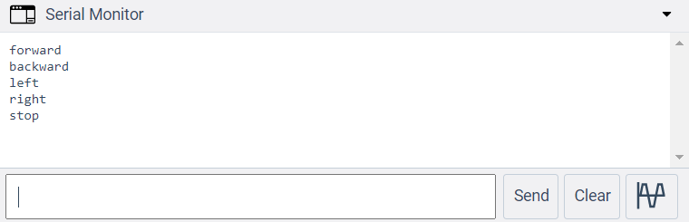

Submitted by,

SHALINI VISWANATH S,

Puducherry Technological University.